**Project Planning Phase**

**Project Planning Template (Product Backlog, Sprint Planning, Stories, Story points)**

|  |  |
| --- | --- |
| Date | 3 november 2023 |
| Team ID | To be added |
| Project Name | A Reliable Energy Consumption Analysis System For Energy-Efficient Appliances |
| Maximum Marks | 8 Marks |

**Product Backlog, Sprint Schedule, and Estimation (4 Marks)**

Use the below template to create product backlog and sprint schedule

|  |  |  |  |  |  |  |
| --- | --- | --- | --- | --- | --- | --- |
| **Sprint** | **Functional**  **Requirement (Epic)** | **User Story**  **Number** | **User Story / Task** | **Story Points** | **Priority** | **Team**  **Members** |
| Sprint-1 | Import libraries and load data  Data preprocessing | USN-1 | This code section performs data cleaning and preprocessing, handling missing values, converting date and time to datetime format, extracting relevant features, applying one-hot encoding, creating a binary weekend flag, renaming columns, calculating total energy consumption, aggregating appliance data, and setting 'datetime' as the index. |  | Low |  |
| Sprint-2 | Feature engineering and target variable  Model training and evaluation  User input and prediction | USN-2 | Defines features and the target variable, splits data into train and test sets, trains a RandomForestRegressor model, evaluates it using MSE, MAE, and R-squared. It then accepts user input, converts it to a DataFrame, performs one-hot encoding, predicts 'Global_active_power', and displays the prediction. |  | High |  |
| Sprint-3 | Appliance usage analysis | USN-3 |  |  | High |  |
| Sprint-4 | Energy usage alert | USN-4 | Compares user appliance usage to average usage for the selected period  Provides insights into appliance usage patterns |  | Medium |  |
| Sprint-5 | Creation of dashboard | USN-5 | page banner was fixed at width 100% and height of 200px and the heading of RECSEA was used with font family Blockhead |  | Medium |  |
| Sprint-6 | Creation of energy calculator | USN-6 | the description of the project was under a div element which makes it easy to use and edit |  | High |  |
| Sprint-7 | Frontend & backend integration | USN-7 |  |  | Medium |  |

**Project Tracker, Velocity & Burndown Chart: (4 Marks)**

|  |  |  |  |  |  |  |
| --- | --- | --- | --- | --- | --- | --- |
| **Sprint** | **Total Story Points** | **Duration** | **Sprint Start Date** | **Sprint End Date (Planned)** | **Story Points**  **Completed (as on**  **Planned End Date)** | **Sprint Release Date (Actual)** |
| Sprint-1 | 20 | 2 Days | 22 Oct 2023 | 23 Oct 2023 | 20 | 22 Oct 2023 |
| Sprint-2 | 20 | 6 Days | 24 Oct 2023 | 29 Oct 2023 | 17 | 30 Oct 2023 |
| Sprint-3 | 20 | 3 Days | 30 oct 2023 | 1 Nov 2023 | 20 | 31 Oct 2023 |
| Sprint-4 | 20 | 4 Days | 2 Nov 2023 | 5 Nov 2023 | 20 | 5 Nov 2023 |
| Sprint-5 | 20 | 2 Days | 6 Nov 2023 | 7 Nov 2023 | 15 | 9 Nov 2023 |
| Sprint-6 | 20 | 3 Days | 7 Nov 2023 | 9 Nov 2023 | 20 | 9 Nov 2023 |
| Sprint-7 | 20 | 4 Days | 14 Nov 2023 | 17 Nov 2023 | 20 | 17 Nov 2023 |

**Velocity:**

Imagine we have a 10-day sprint duration, and the velocity of the team is 20 (points per sprint). Let’s calculate the team’s average velocity (AV) per iteration unit (story points per day)

Sprint 1: AV=20/2=10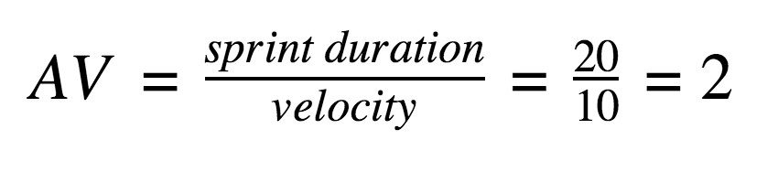  
Sprint 2: AV=20/6=3.33  
Sprint 3: AV=20/3=6.66  
Sprint 4: AV=20/4=5  
Sprint 5: AV=20/2=10  
Sprint 6: AV=20/3=6.66  
Sprint 7: AV=20/4=5

**Burndown Chart:**

